Master  Photography  Checklist  2019A | 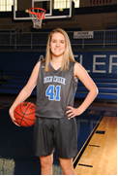 | 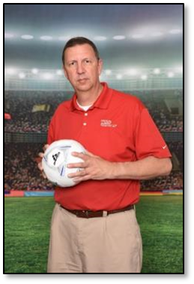 | 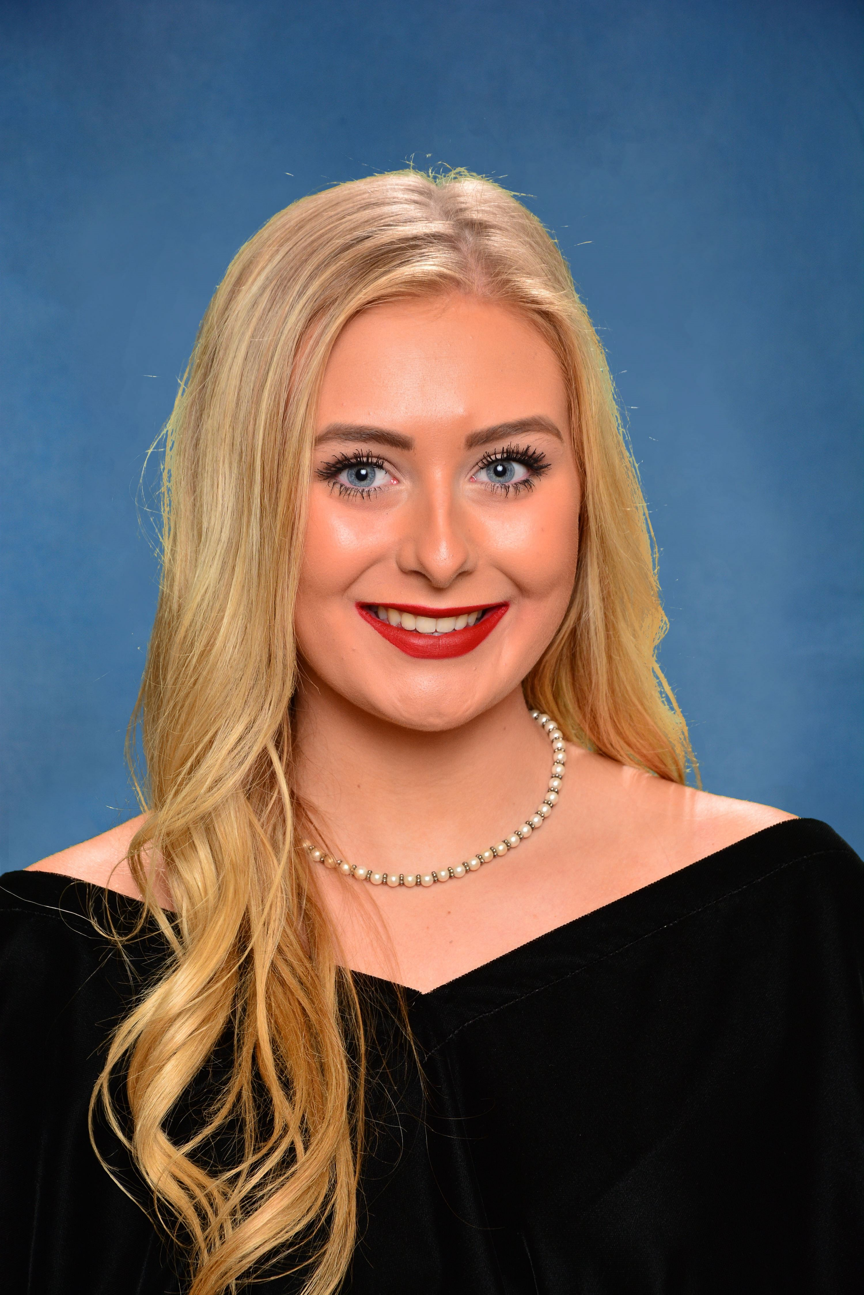 | 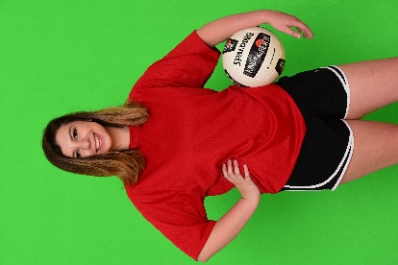 | 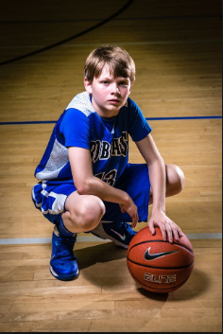 | 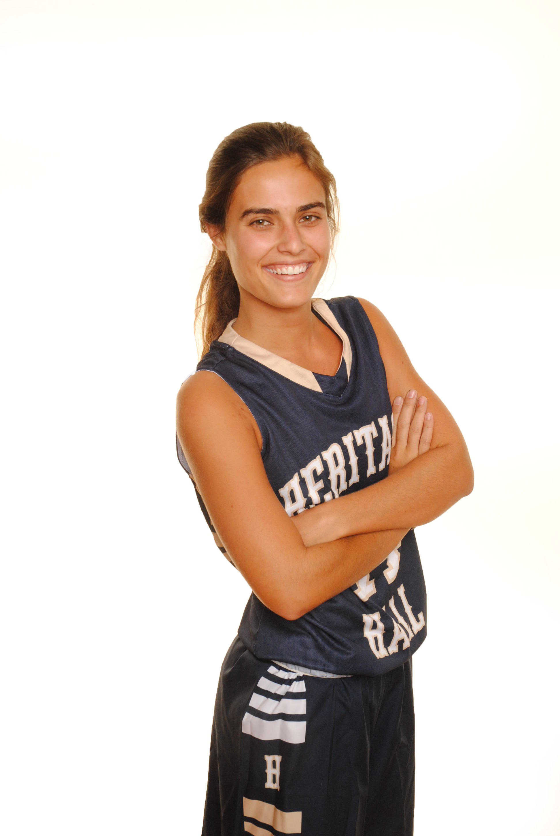 | 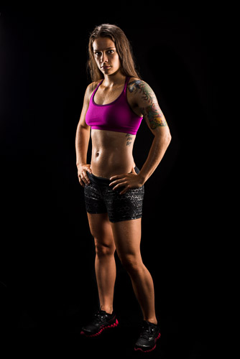 | 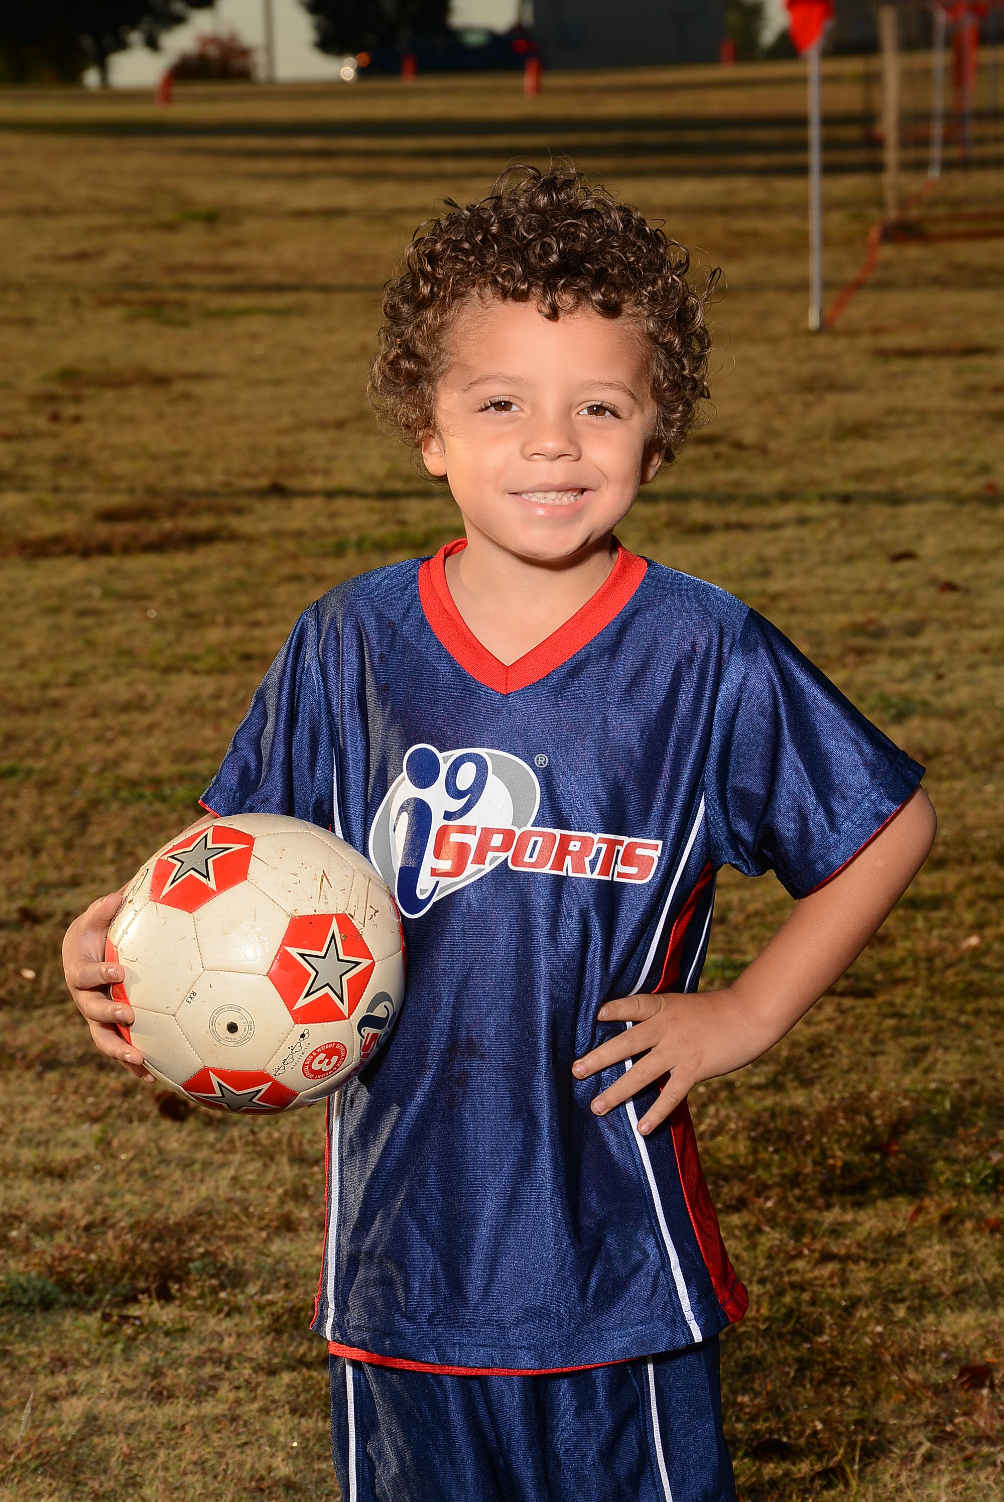 | 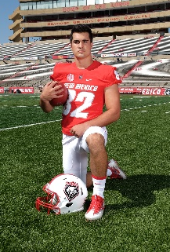 | 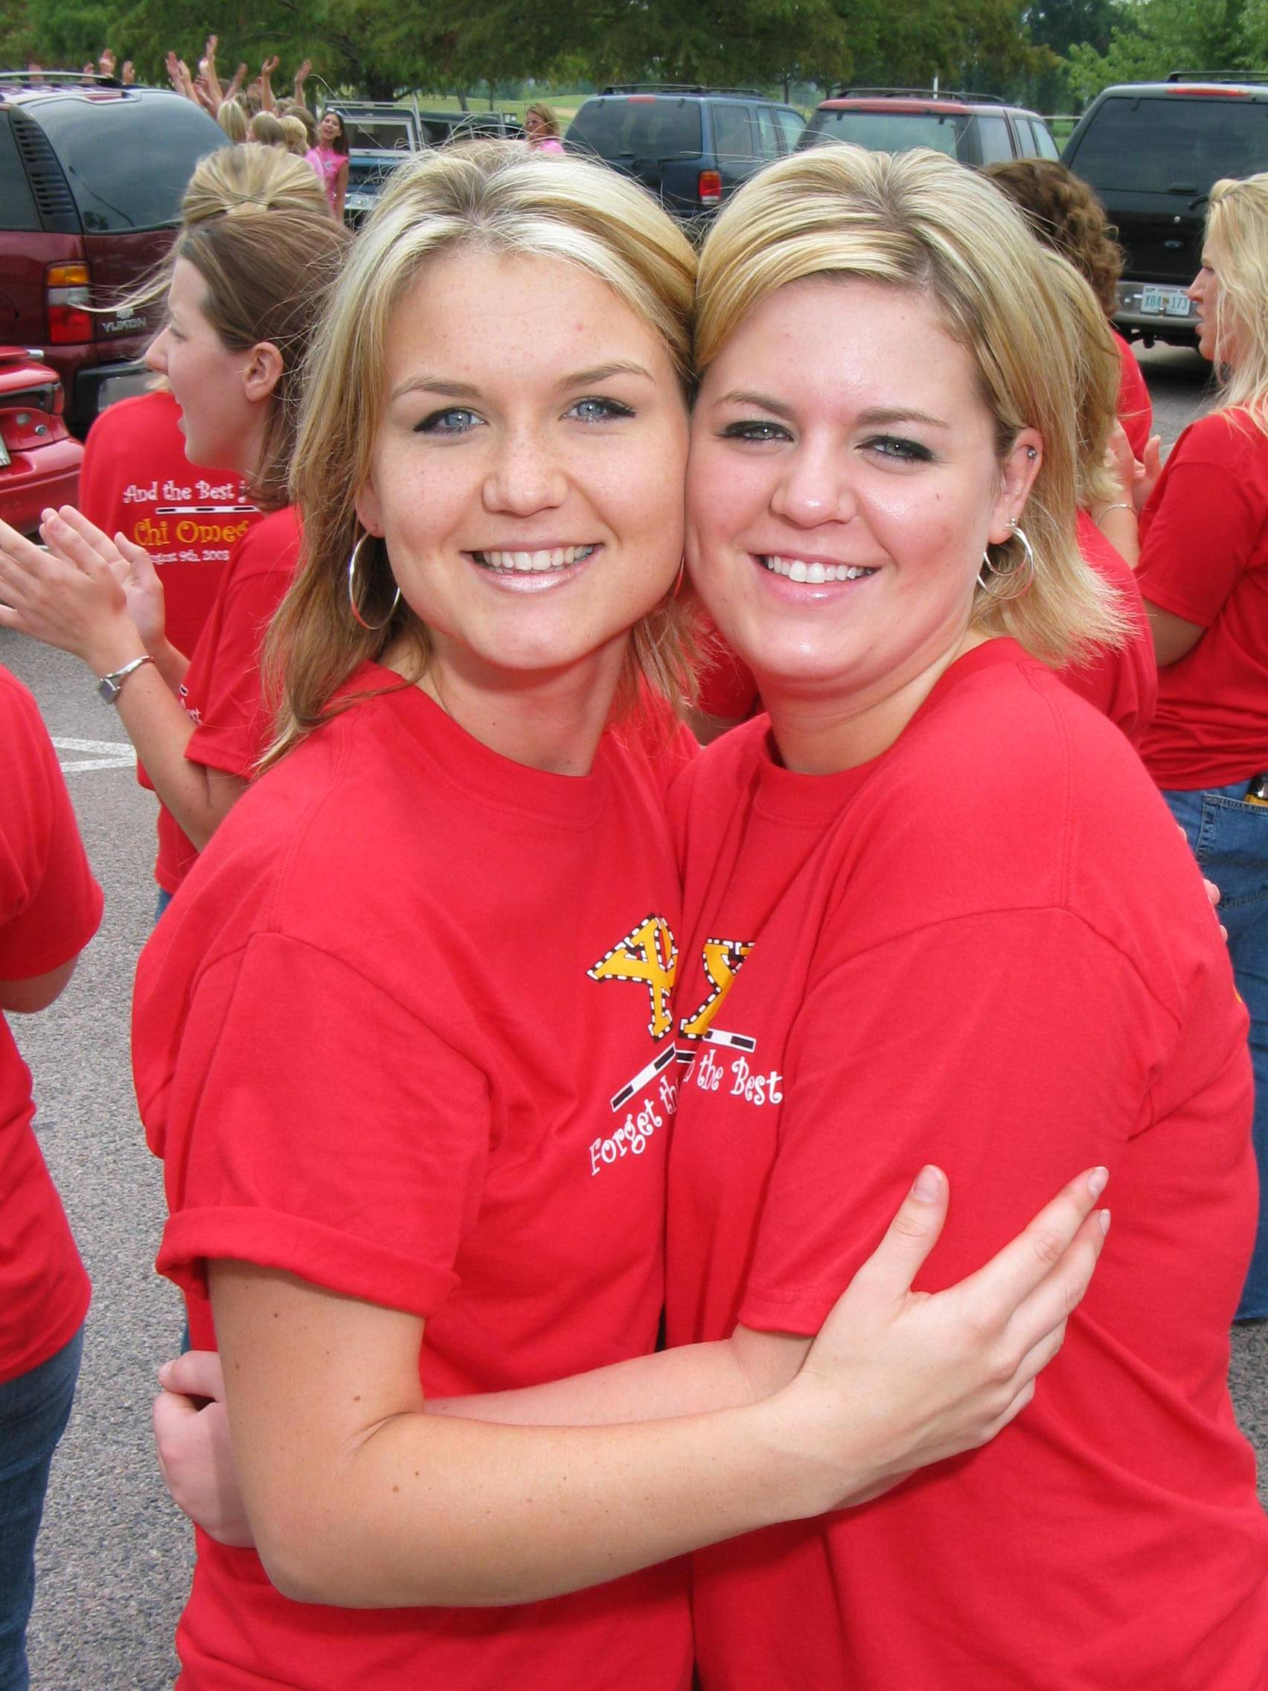 | 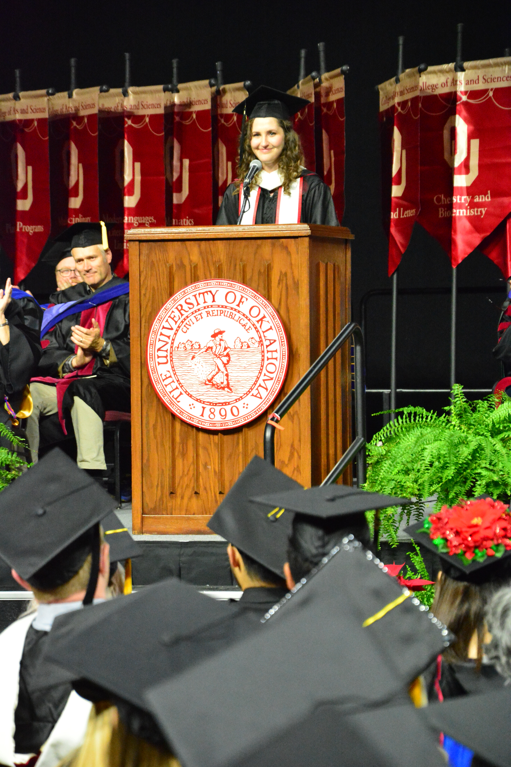
Nikon D7500  Nikon D7200  Nikon D7100 | ❶ | ❷ | ❸ | ❹ | ❺ | ❻ | ❼ | ❽ | ❾ | ❿ | ❶❶
Nikon D7500  Nikon D7200  Nikon D7100 | Indoor  w/ Natural  Background | PhotoRealistic  Background | Portrait BG  w/ Hairlight | Chroma-Key | Dramatic | Hi Key | Low Key | Outdoor  Early  Morning | Outdoor  Day | Party Pic | PR
Shooting Mode | Manual | Manual | Manual | Manual | Manual | Manual | Manual | Manual | Manual | Program | Manual
ISO | ISO 800 | ISO 800 | ISO 800 | ISO 800 | ISO 800 | ISO 800 | ISO 800 | ISO 800 | ISO 100 | ISO 200  Auto ISO3200  Minimum  Shutter Speed  to 1/125 | ISO 3200
Shutter Speed | 1/125 | 1/125 | 1/125 | 1/125 | 1/125 | 1/125 | 1/125 | 1/60-250 | 1/30-250 | ISO 200  Auto ISO3200  Minimum  Shutter Speed  to 1/125 | 1/125-500
Aperture | f/8 | f/8 | f/8 | f/8 | f/8 | f/8 | f/8 | f/11 | f/11 | ISO 200  Auto ISO3200  Minimum  Shutter Speed  to 1/125 | f/5.6
WB White Bal | 5560 Kelvin | 5560 Kelvin | 5560 Kelvin | 5560 Kelvin | 5560 Kelvin | 5560 Kelvin | 5560 Kelvin | 5560 Kelvin | 5560 Kelvin | 5560 Kelvin | Auto
Quality | S Basic | S Basic | S Basic | S Basic | S Basic | S Basic | S Basic | S Basic | S Basic | S Basic | L Basic
Main Light
Light to Subject | 10’ @ 0° | 10’ @ 0° | 10’ @ 0° | 10’ @ 0° | 7’ @ 30° | 10’ @ 0° | 7 @’ 30° | 10’ @ 0° | 10’ @ 0° | Varied | Varied
Modifier | 60” Umbrella | 60” Umbrella | 60” Umbrella | 60” Umbrella | 60” Umbrella | 60” Umbrella | 60” Umbrella | 8.5” Reflector | 8.5” Reflector | Speedlight | --
Meter Reading | f/8 | f/8 | f/8 | f/8 | f/4.5 | f/8 | f/8 | f/10 | f/10 | -- | --
Secondary Light |  |  | Hairlight | BG Fill | Rimming | Backlights | Rimming
Light to Subject | -- | -- | Centered  Over  Background | 3’ from BG  on ball side | 5’ @ 270° | On each  Side of  Lastolite | 5’ @  90° & 270° | -- | -- | -- | --
Modifier | -- | -- | Reflector  30° Grid  Diffusion Sock | Reflector  Diffuser Sock | Reflector  Diffuser Sock | Two  Reflectors | Two  Strip Domes  w/ Grids | -- | -- | -- | --
Meter Reading | -- | -- | f/5.6 | f/5.6 | f/8 | f/8 Across BG | f/4.5 | -- | -- | -- | --

❶ Indoor w/ Natural Background  | ❷  Background  | ❸  Background w/ Hairlight  | ❹  Chroma-Key 
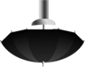    10’ to Light  7’-10’ to Camera | 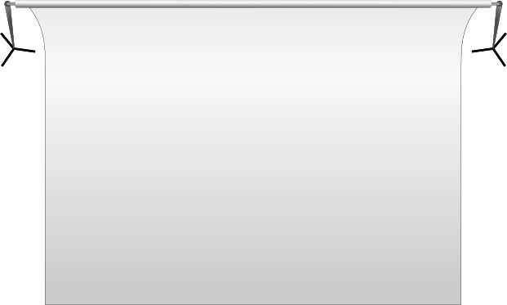  10’ to Light  7’-10’ to Camera  4’ | 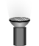  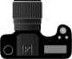  10’ to Light  7’ to Camera  4’  Can be used for Chroma-Key Portraits/Head Shots too | 10’ to Light  7’-10’ to Camera
❺  Dramatic  | ❻  Hi Key  | ❼  Low Key  | ❽  Outdoor 
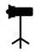  5’  7’  7’-10’ to Camera | 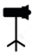  10’ to Light  7’ to Camera  Lastolite HiLite  6” | 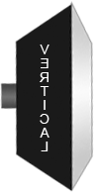    7’-10’ to Camera  5’  5’  7’  4’ | 10’ to Light  7’ to Camera

Indoor/Outdoor Portrait/Sports Equipment Checklist – 2019A
Camera Rolling Case |  | PhotoMatch Kit
 Camera Body |  |  PhotoMatch Tablet x 2 (Charged, Updated, Cleansed)
 18-140mm Lens w/ Lens Hood |  |  Tablet Charger x 2 (appropriate to tablet model)
 Camera Battery x 2 (Charged) |  |  Tablet Hood
 Camera Battery Charger |  |  Hot Spot Router & Power Supply
 Sync Cord x 2 (appropriate size for studio light) |  |  Registration Tablets x 2
 Hot Shoe Adapter x 2 |  | Job Bag
 Studio Light x 2 |  |  Zippered Card Pouch
 Power Cord x 2 |  |  Memory Card Envelope x3
 CyberSync Transmitter x 2 |  |  Memory Card x 3
 CyberSync Receiver x 2 |  |  Schedule
 CyberSync Sync Cord x 2 (appropriate size for studio light) |  |  Stringer x 2
 Diffusion Sock |  |  Pens x 20
 30 degree Honeycomb Grid |  |  Pose Guide
 Light Meter w/ fresh battery |  |  Backup Blank Barcoded Sequence Cards
 Gaffer Tape |  | Backup Kit
 Vagabond charger |  |  Camera, Lens, Battery
 Vagabond w/ 2 Power Packs – Charged |  |  Studio Light
 Tape Measure |  |  Scanner
 Hoodman Viewer |  |  25’ Extension Cord x 3 & Power Strip
 Tablet Bracket |  | Misc
 USB Camera Cable x 2 |  |  Subject Posing Stool (If appropriate to photo session)
 USB Adapter Splitter x 2 |  |  Photographer Stool
 Scanner |  |  Photo Props
Rolling Stand Case 1 |  |  Horizontal Banner
 Heavy Duty Light Stand |  |  Sample Display
 Lightweight Hairlight/Accent Light Stand |  |  Retractable Banner
 60” White Umbrella |  |  Photographer Sun Umbrella
 8.5 Reflector |  |  Water/Cooler
 Rotating bracket for camera |  |  Bench (es)
 Light stand mount for camera |  |  Tent
 Tripod with Tripod Head and Tripod Plate |  |  Table(s)
Rolling Stand Case 2 |  | High Key Extra Gear
 5x7 Green & Blue Screen Backgrounds |  |  Extra Light, Reflector, Receiver, Power Cord, Stand
 5x7 Background Stand w/ leg extenders |  | Low Key Extra Gear
 10x12 Green Screen Background |  |  Extra Light, Receiver, Power Cord, Stand
 Background Stands & Crossbar Poles for 10x12 |  |  2 Strip Domes with Grids
 Background Clamps

Softball  Baseball |  | Basketball  Volleyball  Soccer |  | Football |  | Cross Country |  | Tennis |  | Cheerleader | Band | Little League  Baseball | Little League  Indoor Soccer | Real Little League  Indoor Soccer | Hockey  Wrestling  Lacrosse
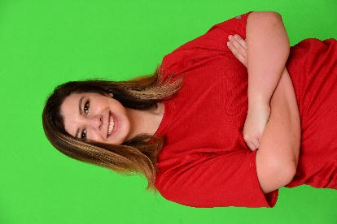 |  |  |  |  |  |  |  |  |  |  | 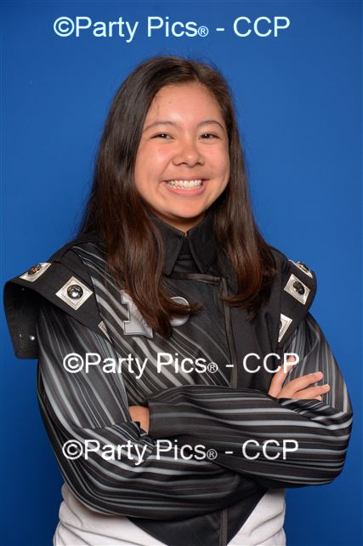 | 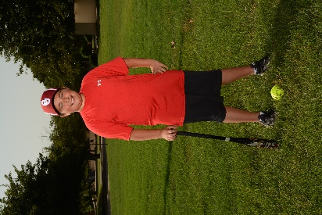 | 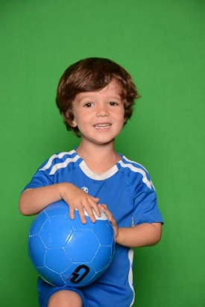 | 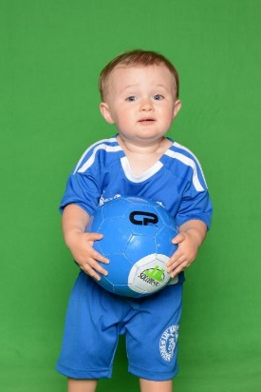 | 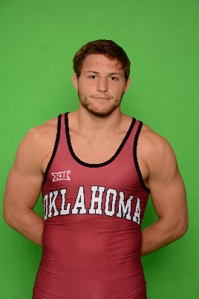
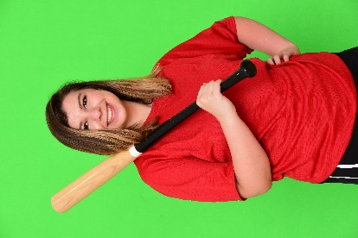 |  | 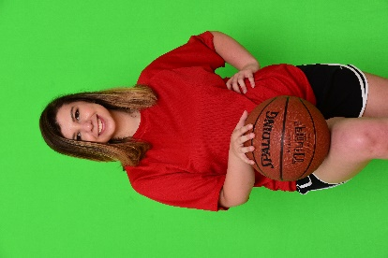 |  | 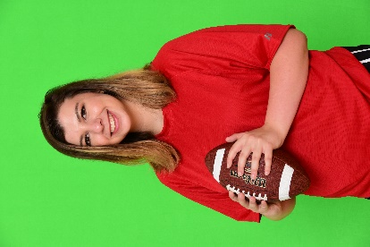 |  | 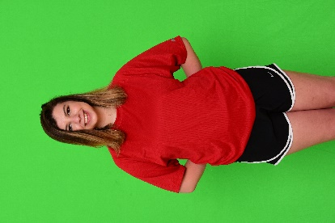 |  | 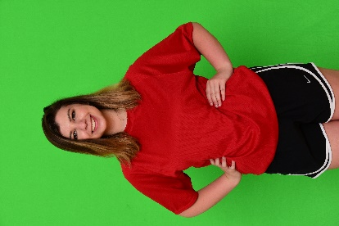 |  | 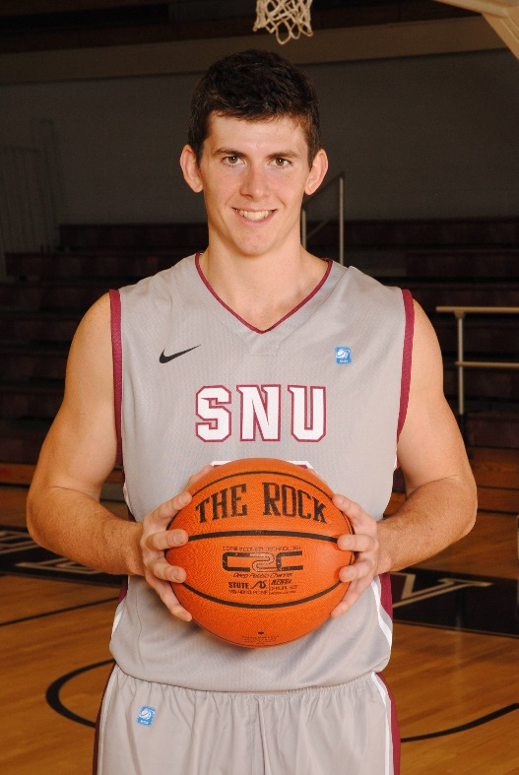  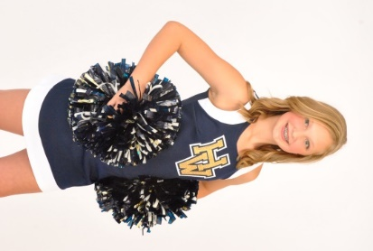 | 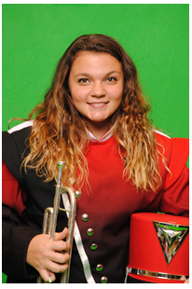 | 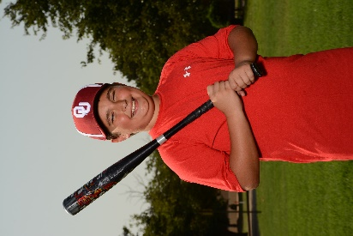 | 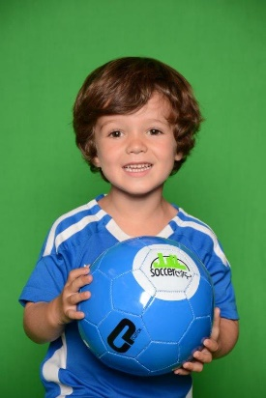 | 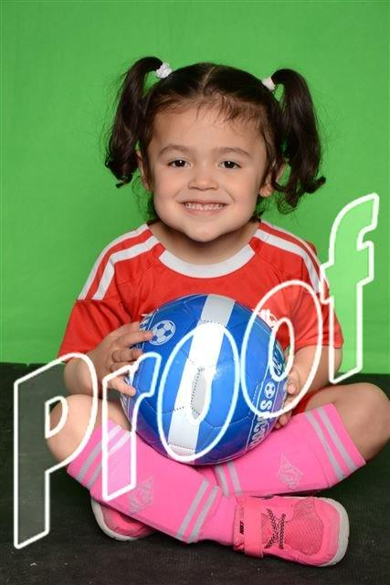 | 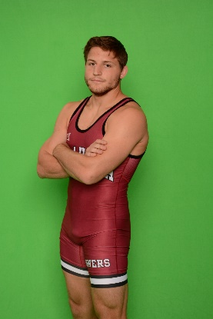
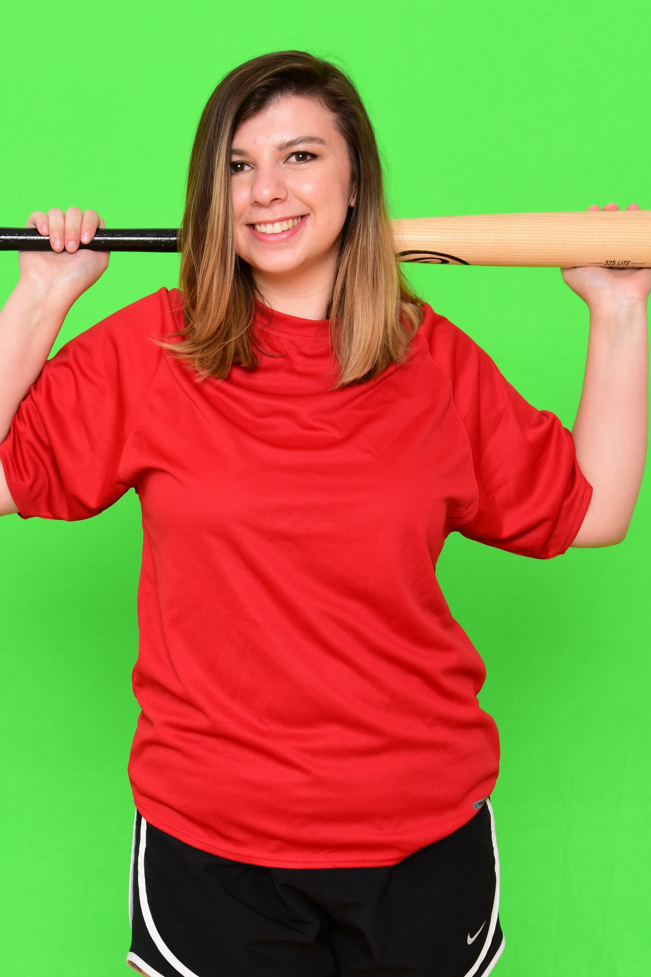 |  |  |  | 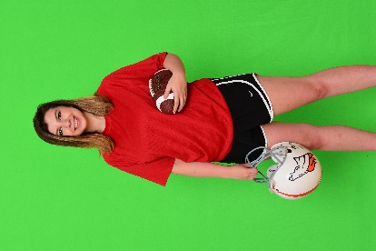 |  |  |  | 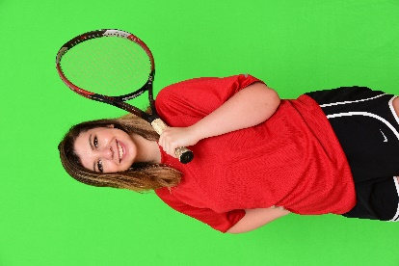 |  | 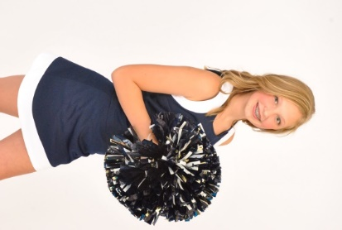 | 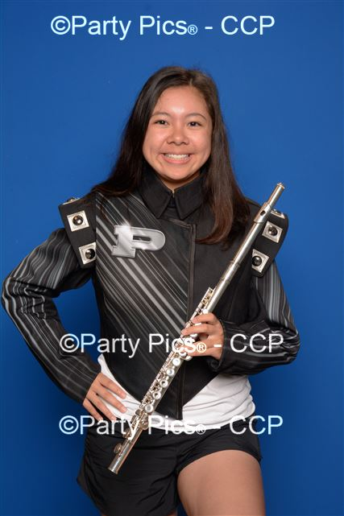 | 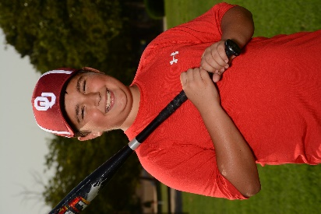 | 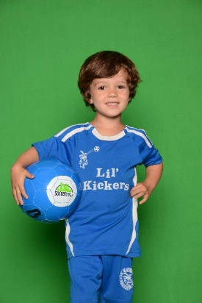 | 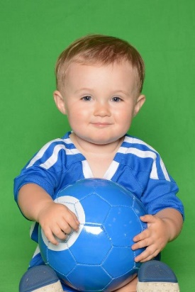 | 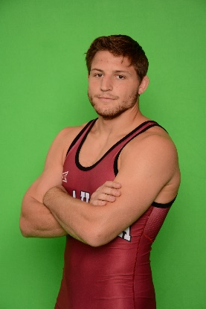
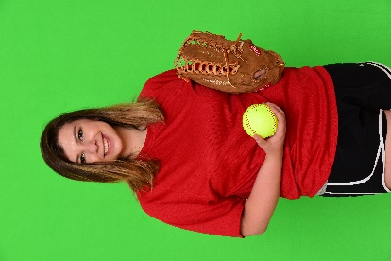 |  | 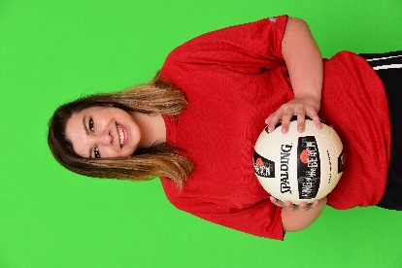 |  |  |  | 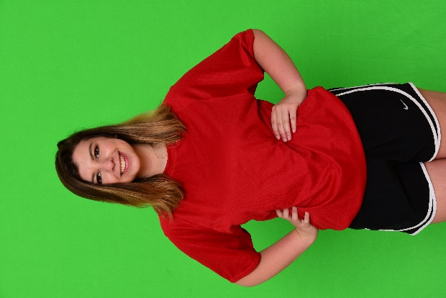 |  | 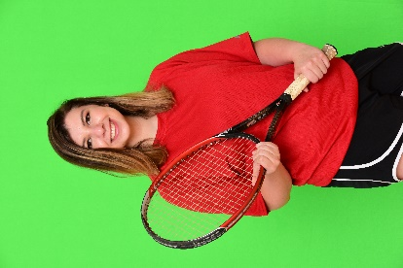 |  | 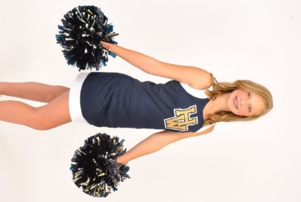 | 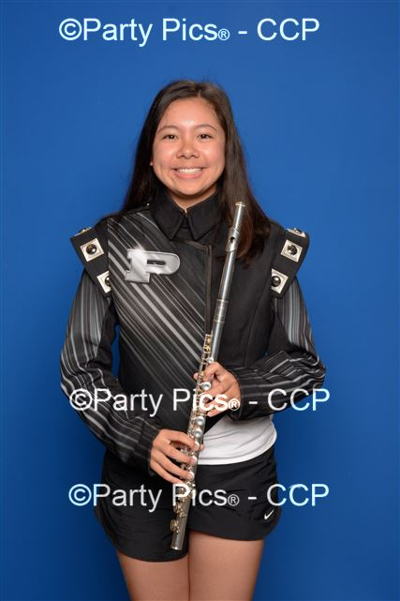 | 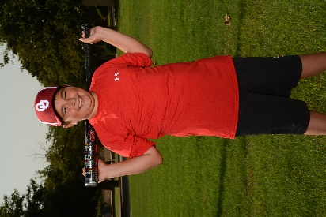 | 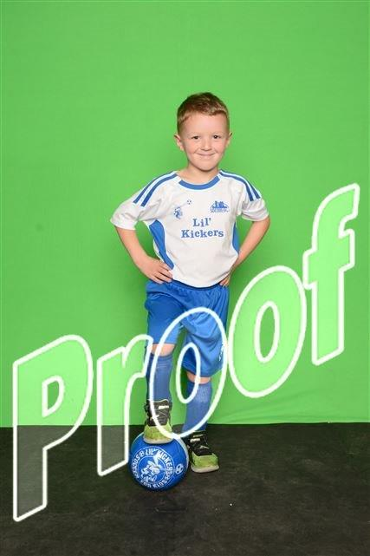 | 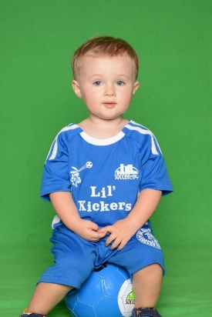 | 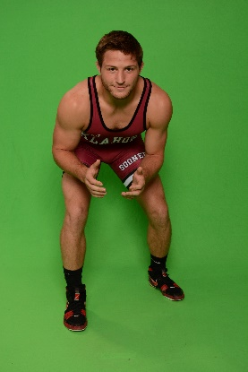
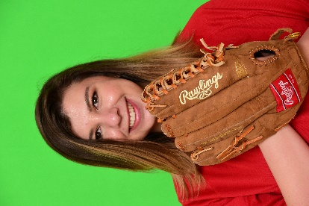 |  | 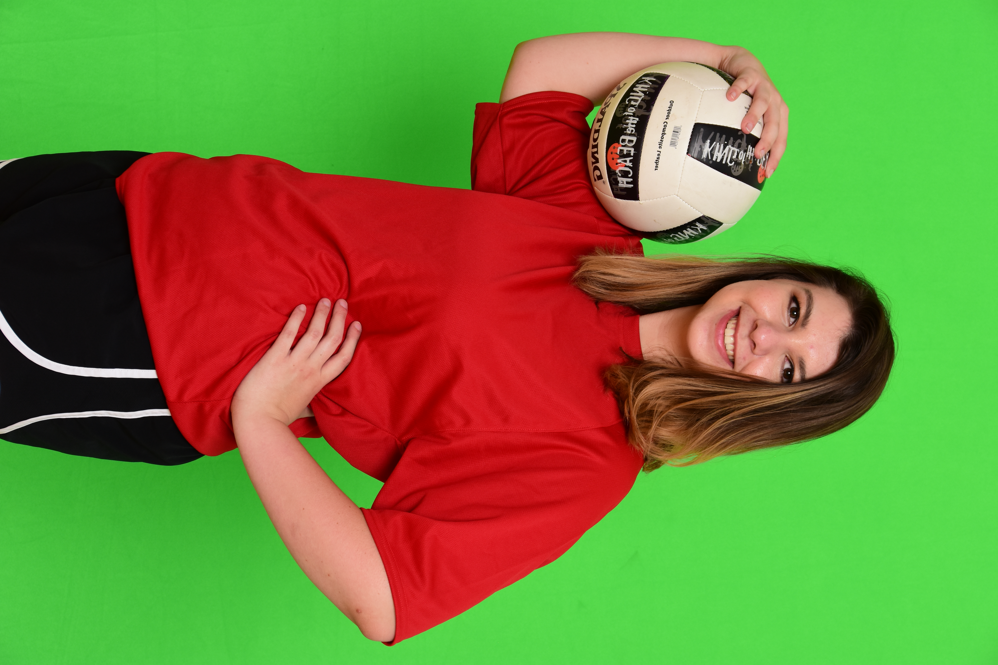 |  | 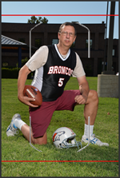 |  | 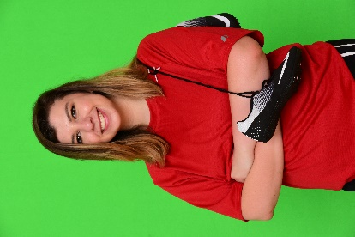 |  | 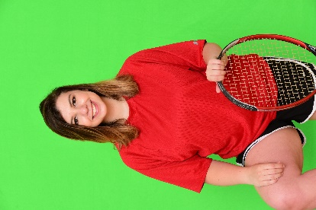 |  | 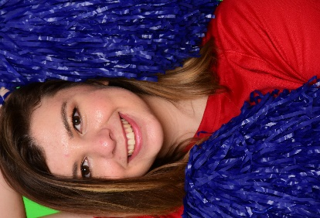 | 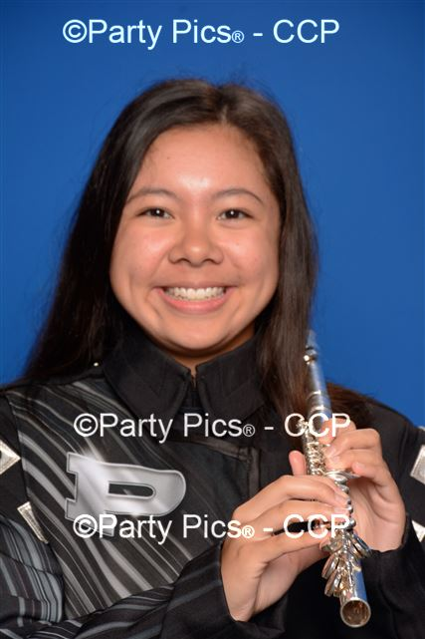 | 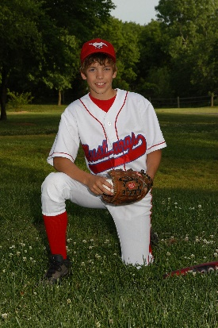 |  |  | 

