2020 Emails for Late Summer-Early Fall-Back to School
These emails are available in CORE and can be added anytime to your marketing plan.
Contact CCS support today, ccssupport@candid.com, for assistance in setting up these email campaigns using our FREE, consolidated email marketing tools in CCS’ CORE software.
NOTE: By requesting help in setting up email campaigns you acknowledge that CCS is not financially responsible for the inclusion/exclusions of particular events/offers/markets in email marketing. You will share the opportunity to review emails and settings before marketing begins. CCS is happy to work with you to refine your campaign. We encourage accounts to review email reporting to make sure campaigns are going as you expect. Support is happy to give training on email reporting as well.
Back to School Masks Email 1 – Tuesday, August 4th
- Concept: Back to School themed -order face masks with images from recent events or upload your own
- NOTE: No savings…just a link to images/face masks.
- Suggested Subject line: We’ve got your face mask just in time for Back to School!
- Suggested pre-header text: If you have to wear one – make it one you create. Order now!
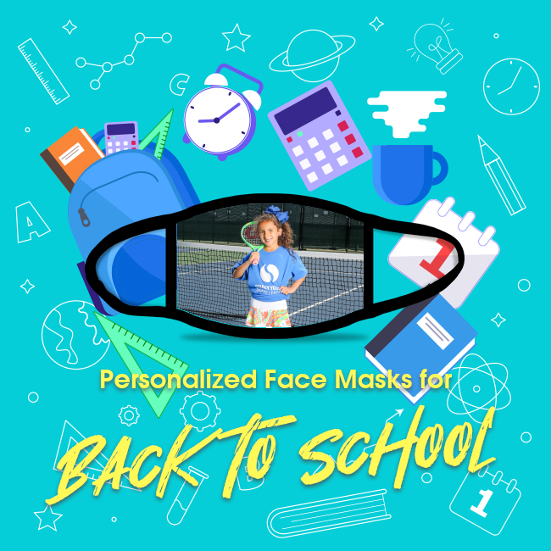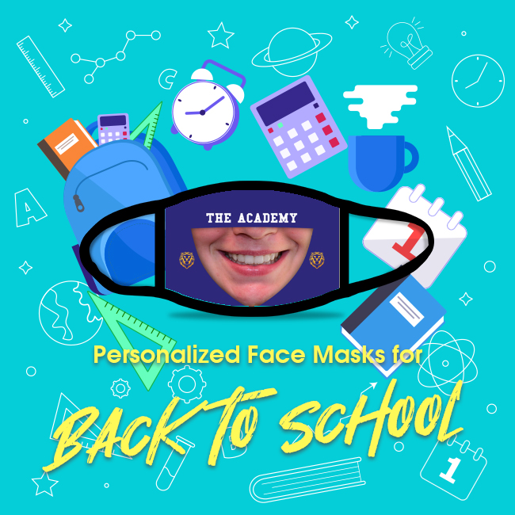
Back to School Sale Email 1 – Friday, August 7th:
- Concept: 3- Day Sale Friday, August 7th thru Sunday, August 9th 2020
- DON’T FORGET to set up code BTS10 for 10% savings. We suggest extending the savings one day so it will expire August 10th.
- Suggested subject line: Back to School Stock Up & Get 10% Off!
- Suggested pre-header text: Enter code BTS10 at check out to save 10% on photos and gift items. Savings good now through 11:59pm central time on Sunday, August 9th.
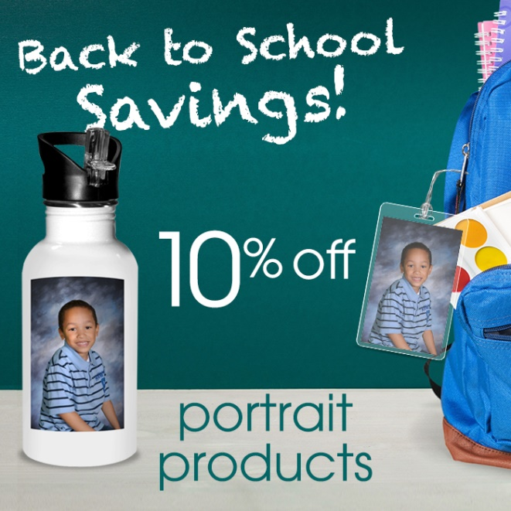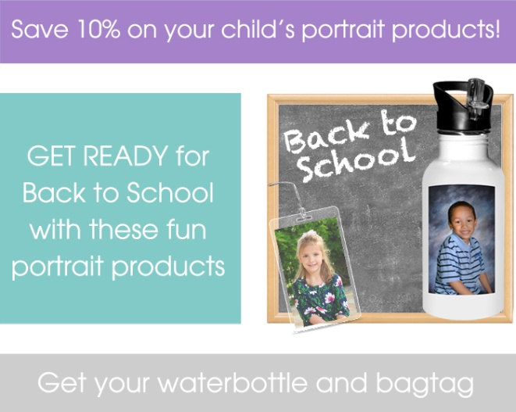
Back to School Sale Email 2 – Sunday, August 9th:
- Concept: 3- Day Sale Friday, August 7th thru Sunday, August 9th 2020
- DON’T FORGET to set up code BTS10 for 10% savings. We suggest extending the savings one day so it will expire August 10th.
- Suggested subject line: Last Day to save during our Back to School Stock Up Sale!
- Suggested pre-header text: Enter code BTS10 at check out to save 10% on photos and gift items. Savings good now through 11:59pm central time on Sunday, August 9th.

Back to School Masks Email 2 – Friday, August 14th
- Concept: Back to School themed -order face masks with images from recent events or upload your own
- NOTE: No savings…just a link to images/face masks.
- Suggested Subject line: Personalize your face mask! It’s a blank canvas that you can build on.
- Suggested pre-header text: If you have to wear one – make it one you create. Order now!
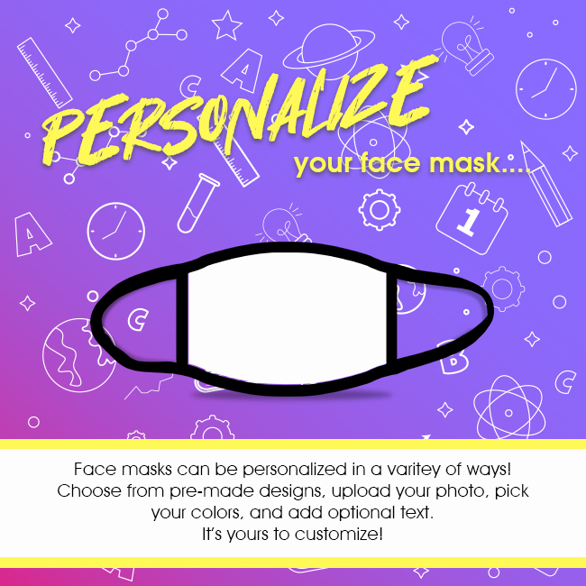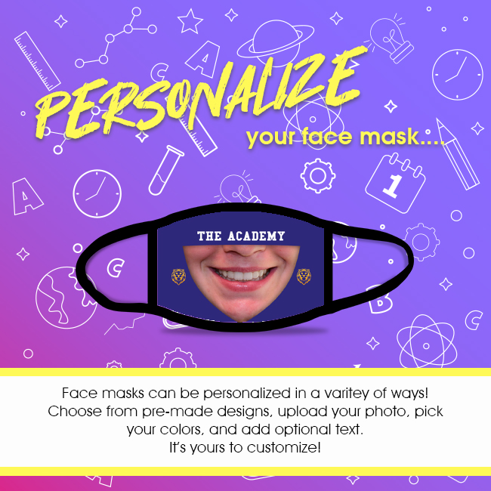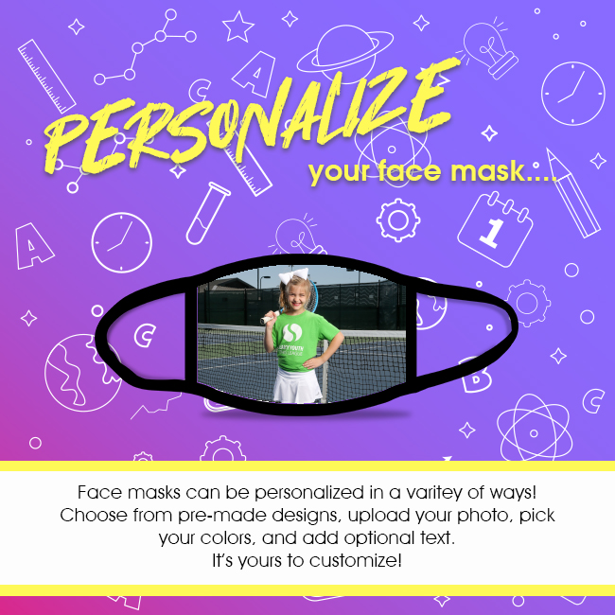
Back to School email 3 – Wednesday, August 19th:
- Concept: Back to School themed -order face masks with images from recent events or upload your own
- NOTE: No savings…just a link to images/face masks.
- Suggested Subject line: Personalize your face mask with your team picture!
- Suggested pre-header text: If you have to wear one – make it one you create. Order now!
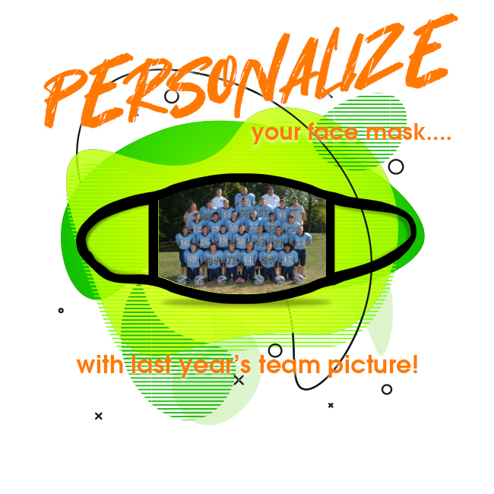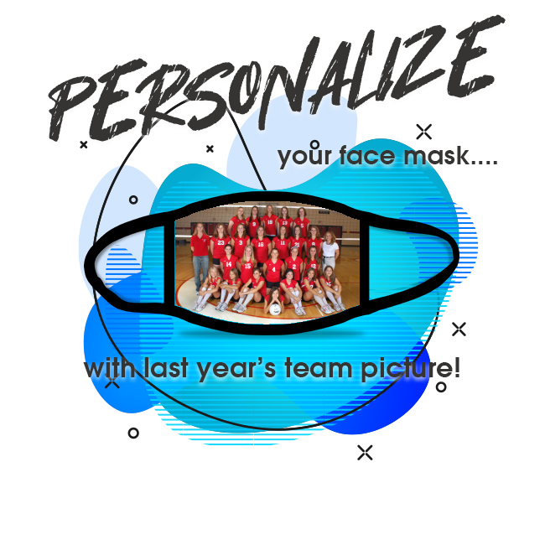
Back to School email 4 – Friday, August 21st
- Concept: Back to School themed -order face masks with images from recent events or upload your own
- NOTE: No savings…just a link to images/face masks.
- Suggested Subject line: The face mask is the new sports photo button!
- Suggested pre-header text: If you have to wear one – make it one you create. Order now!
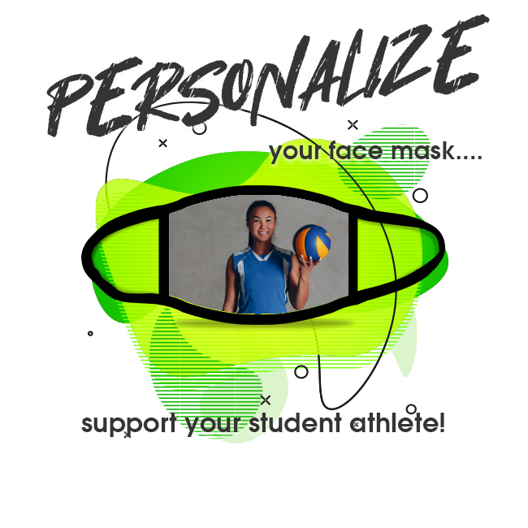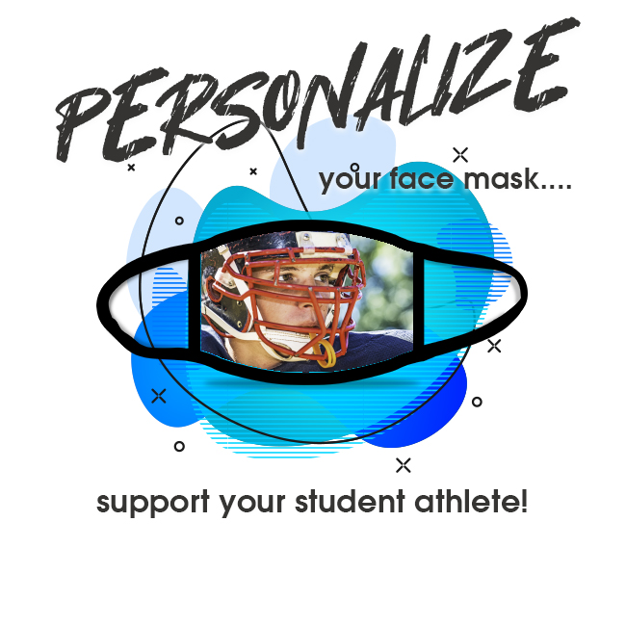
Labor Day email 1 – Saturday, September 5th:
- Concept: 3- Day Sale Saturday, September 5th thru Monday, September 7th 2020
- DON’T FORGET to set up code LABOR10 for 10% savings. We suggest extending the savings one day so it will expire September 8th or 9th.
- Suggested subject line: 3 Day Weekend = 3 Day Sale!
- Suggested pre-header text: We think you deserve to save this weekend! Enter code LABOR10 at check out to save 10% on photos and gift items. Savings good now through 11:59pm central time on Monday, September 7th.
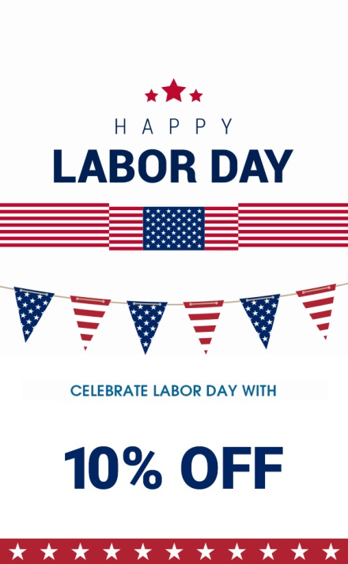
Labor Day email 2 – Monday, September 7th:
- Concept: 3- Day Sale Saturday, September 5th thru Monday, September 7th 2020
- DON’T FORGET to set up code LABOR10 for 10% savings. We suggest extending the savings one day so it will expire September 8th or 9th.
- Suggested subject line: Last Day to Save!
- Suggested pre-header text: We think you deserve to save this weekend! Enter code LABOR10 at check out to save 10% on photos and gift items. Savings good now through 11:59pm central time on Monday, September 7th.
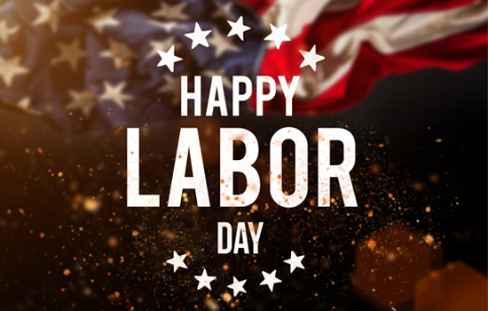
Grandparent’s Day Email 1 – Sunday, September 13th
- Concept: Order portrait products from recent events
- NOTE: No savings…just a link to images.
- Suggested Subject line: Happy Grandparent’s Day! Order photos your grandparents will love!
- Suggested pre-header text: We offer a vast selection of portrait products. Order now!

World Smiley Day Email – Friday, October 2nd
- Concept: Save 10% on Smile Mask Orders
- DON’T FORGET to set up codeMASK10 for 10% savings on masks. We suggest extending the savings one day so it will expire October 3rd.
- Suggested Subject line: It’s World Smiley Day! Save 10% on our Smile Face Masks!
- Suggested pre-header text: Did you know you can still show off your smile through a mask? Enter code MASK10 at check out to save 10% on Smile Face Masks. Savings good now through 11:59pm central time on Friday, October 2nd.

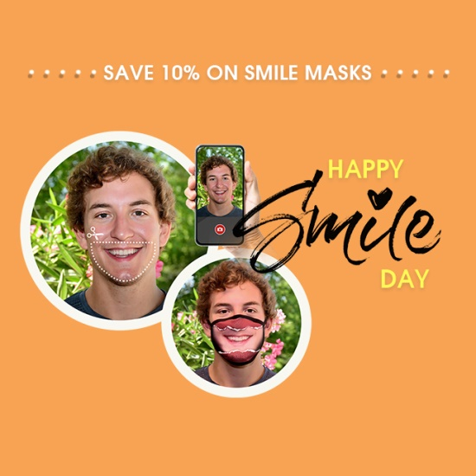


Extra emails you can use
Back to School Emails:
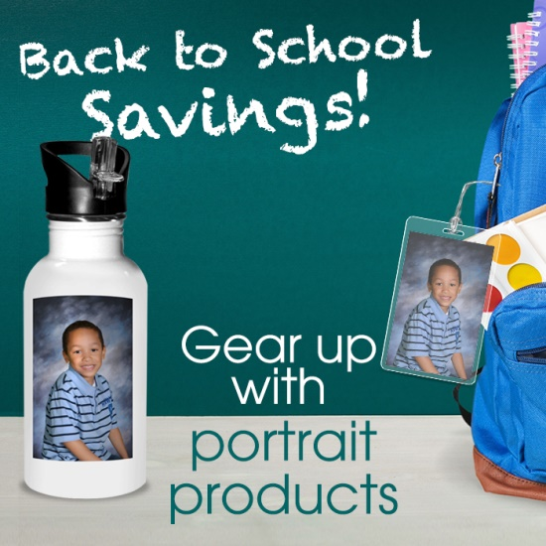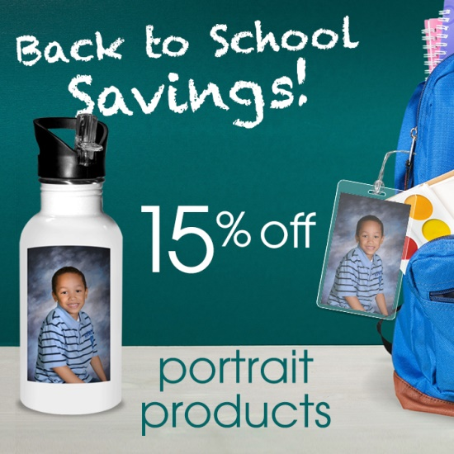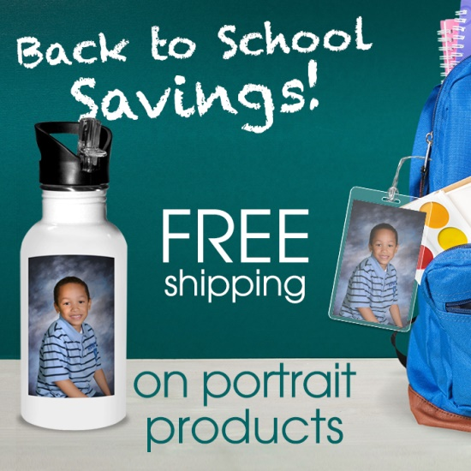

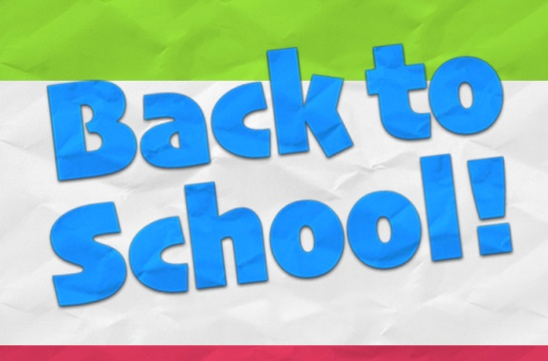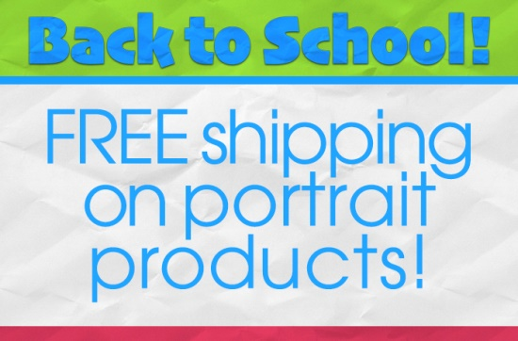

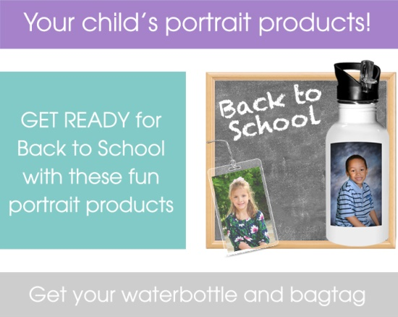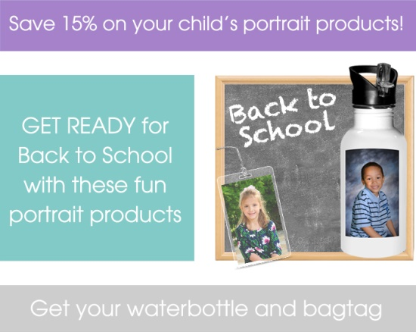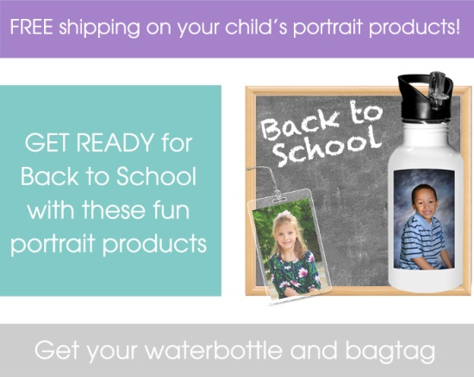

Extra Labor Day Emails:
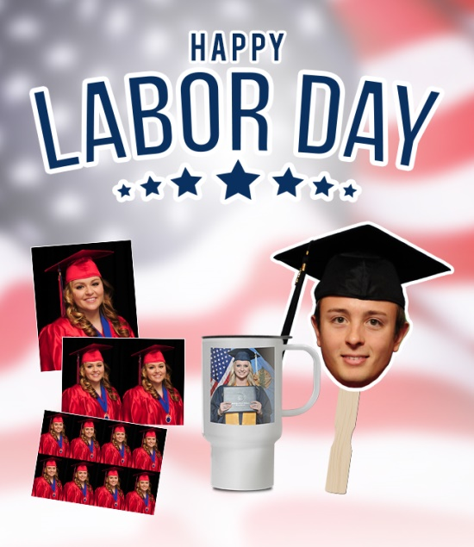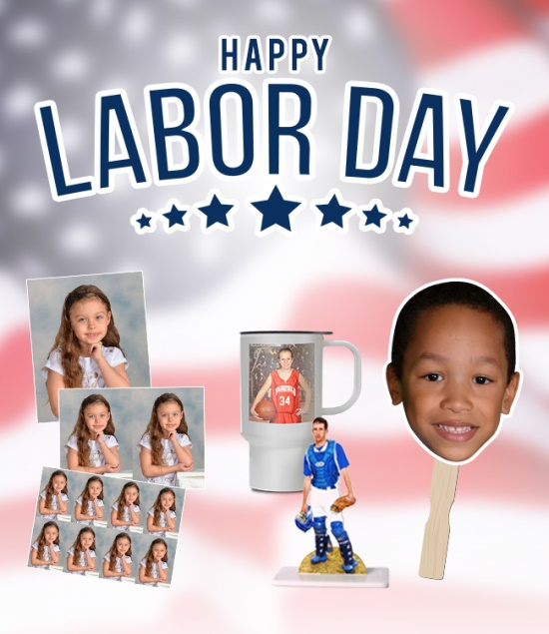




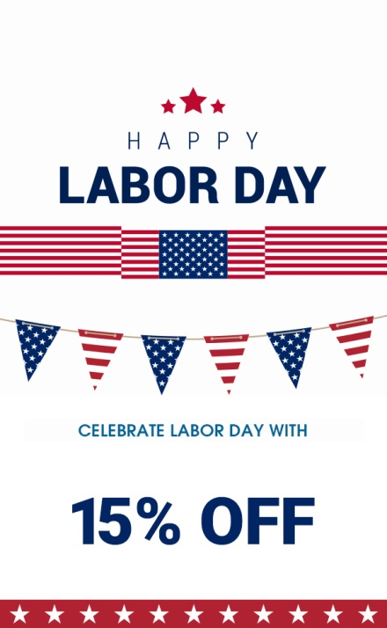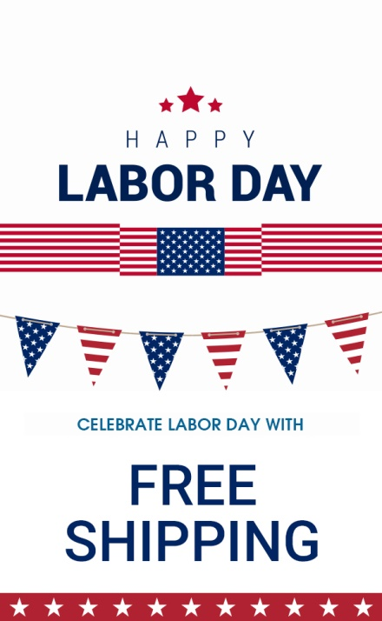

Extra Home Décor Emails:
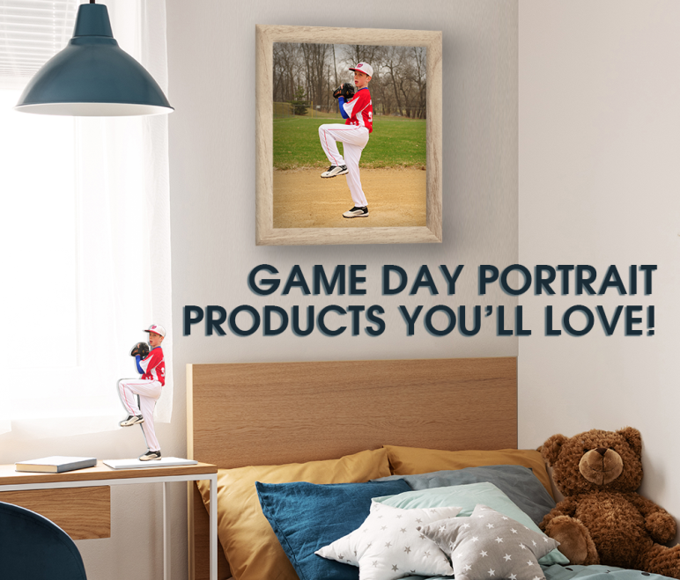
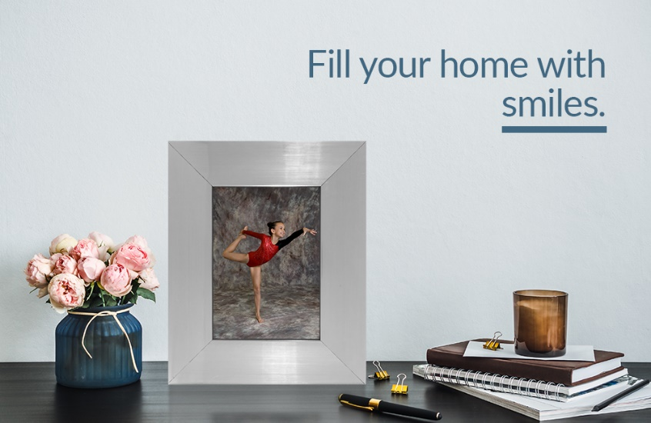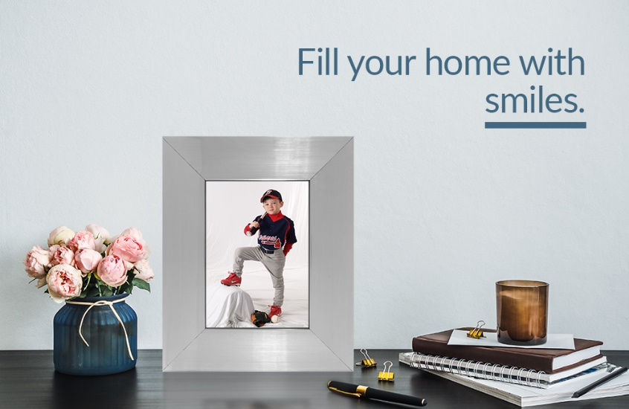
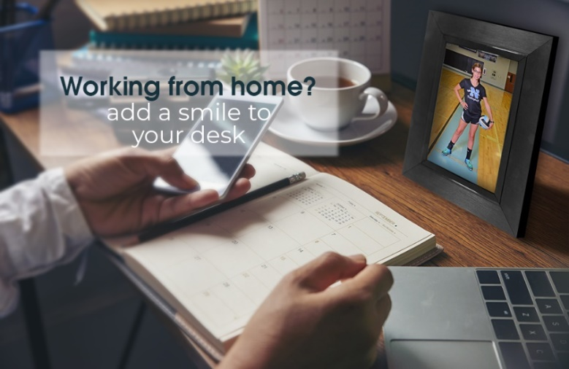
Face Masks: Pop-ups, Email Header/Foots, & Acct. Headers
Acct. Headers


Email Header/Footer
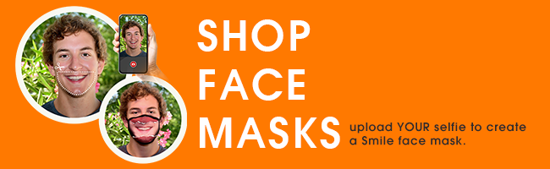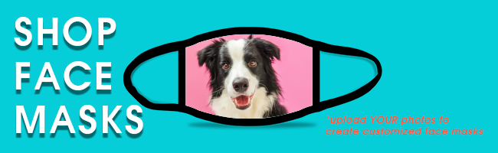
Pop-Ups
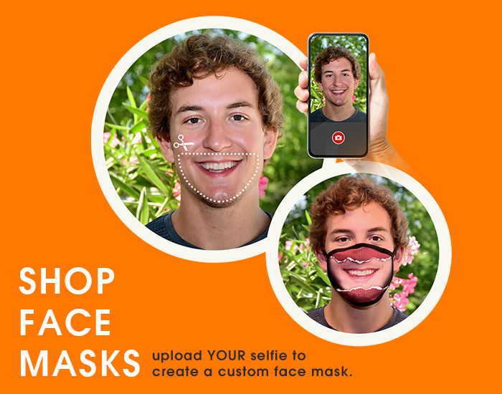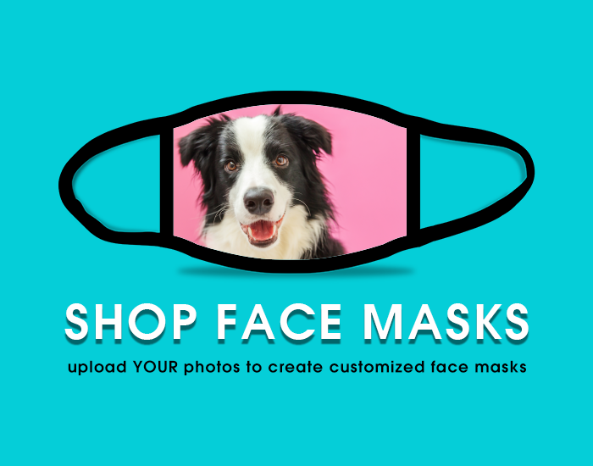
Upload from Home: Pop-ups, Email Header/Foots, & Acct. Headers
Acct. Headers


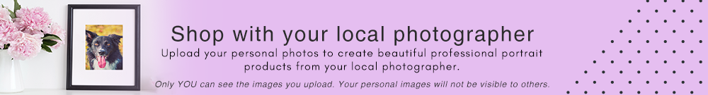

Email Header/Footer
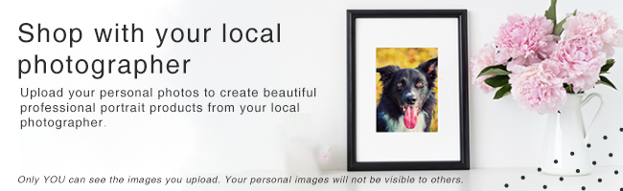
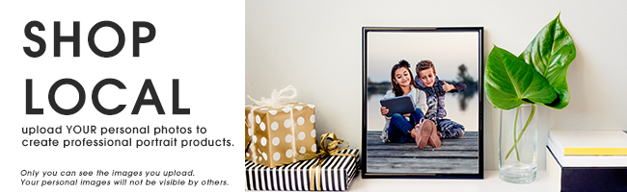
Pop-Ups
