1



**HOW TO ORDER CERTIFIED SAFE BADGES**

*Step by Step Guide*

Candid Color Systems, Inc. / TSS Photography 8/06/2020

How to Order Certified Safe Badges

*Step by Step Guide*

# How to Order Certified Safe Badges 3

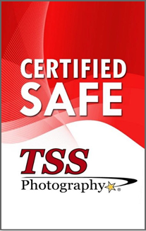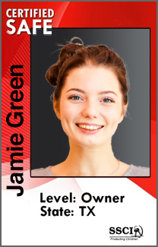

**Badge Front Badge Back**

**IMPORTANT**: This is a non-punched ID badge. It is NOT available as a punched ID badge.

**HOW TO ORDER CERTIFIED SAFE BADGES**

**STEP ONE:** Applicant **MUST** fill out the, “**Background Screening Authorization and Consent”**

form.

* Applicant can be one of the following:
  + Business Owner
  + Officer
  + Director
  + Manager
  + Employee
* Background screening authorization and consent form can be downloaded by selecting one of the links below:
  + [**Click Here to Download Background Screening Authorization (Fillable)**](https://developmentsdottssphotographydotcom.files.wordpress.com/2018/10/background-screening-authorization-consent.pdf)

**STEP TWO**: Fill out the, “**Applicant Information Spreadsheet**”.

* Spreadsheet contains the following **required** information:
  + First name of applicant (FirstName)
  + Last name of applicant (LastName)
  + Job title of applicant (CLevel)
  + Year (CYear)
  + State (State)
* The applicant information spreadsheet can be downloaded by selecting the link below:

# [Click Here to Download Applicant Information Spreadsheet](https://developmentsdottssphotographydotcom.files.wordpress.com/2020/08/applicant-information-spreadsheet_franchisee.xlsx)

**STEP THREE**: Take and/or provide a head shot/image of each applicant.

* Recommend 2:3 (4x6) image ratio
* Recommend consistent/uniform background for all submissions
* Head shot/close up recommended
* Avoid utilizing low resolution images (below 400kb)

**STEP FOUR**: Submit the following items to CCS-TSS HQ.

# Completed Background Screening Authorization and Consent form

1. **Completed Applicant Information Spreadsheet**
2. **Head shot of each applicant**

* Email all items listed above to the following email address: [carols@candid.com](mailto:carols@candid.com)
* Cost of background check is $17.50 per submission/applicant (Includes cost of badge)
* Badges will be mailed directly to franchisee
* Allow 2 to 3 weeks for delivery